Western blotting

Preparation of Whole Cell Lysate
Cell count/10cm dish:
- Harvest cells into 1.5ml Eppendorf tube.
- Add 1ml of PBS into the cells and suspend them.
- Centrifuge at 4000rpm, 4℃ for 1min.
- Remove the supernatant.
- Prepare RIPA lysis buffer described as below.
- Resuspend cells in 100〜200μl of RIPA lysis buffer.
- Incubate them on ice for 30 min and vortex every 10 min.
- Centrifuge them at 15000rpm, 4℃ for 15min.
- Transfer 90μl of the supernatant to clean 1.5ml eppendorf tube.※It can be stored at −90℃.

RIPA lysis solution:
- Stock solution:
1M HEPES(pH7.9) | 3.5ml | 7.0ml | 13.65ml | 27.3ml | 54.25ml | 82.25ml
5M NaCl | 2.1ml | 4.2ml | 8.19ml | 16.38ml | 32.55ml | 49.35ml
10% TritonX-100 | 7.0ml | 14.0ml | 24.5ml | 54.6ml | 108.5ml | 164.5ml
500mM EDTA | 140μl | 280μl | 490μl | 1092μl | 2.17ml | 3.29ml
Total volume | 12.74ml | 25.48ml | 46.83ml | 99.372ml | 197.47ml | 299.39ml

- Final preparation before use:
Stock solution | 182μl | 910μl | 1.82ml | 9.1ml | 18.2ml | 36.4ml
100mM PMSF | 10.0 | 50.0μl | 100μl | 500μl | 1000μl | 2.0ml
0.5mg/ml Pepstatine | 2.0 | 10.0μl | 20.0μl | 100μl | 200μl | 400μl
10mg/ml Leupeptin | 1.0 | 5.0μl | 10.0μl | 50.0μl | 100μl | 200μl
5mg/ml Aprotinine | 2.0 | 10.0μl | 20.0μl | 100μl | 200μl | 400μl
Phosphatase inhibitor | 10.0 | 50.0μl | 100μl | 500μl | 1000μl | 2.0ml
DDW | 793μl | 3.965ml | 7.93ml | 39.65ml | 79.3ml | 158.5ml
Total volume | 1.0ml | 5.0ml | 10.0ml | 50.0ml | 100ml | 200ml
PMSF: serine protease
Pepstatine: Aspartate protease
Leupeptin: serine protease, cysteine protease
Aprotine: cysteine protease
Stored at —20℃.
Phosphatase inhibitor cocktail(EDTA free) (nacalai tesque) Stored at –４℃.

5×SDS Gel-loading buffer:
 | For 1ml | For 15ml | Final concentration
1M Tris-HCl(pH6.8) | 0.25ml | 3.75ml | 250mM
SDS | 80mg | 1.2g | 8%
Bromophenol blue (BPB) | 1mg | 15mg | 0.1%
Glycerol (100% v/v) | 0.4ml | 6ml | 40% (v/v)
MilliQ | 0.25ml | 3.75ml
SDS: Sodium Dodecylsulphate (Sodium Lauryl Sulfate)
Had better weigh powder with weighing paper.
SDS gel-loading buffer (5×) lacking DTT can be stored at RT. Add DTT from a 1M stock (−20℃) just before the buffer is used.

5×SDS Gel-loading buffer with 100mM DTT:
1MDTT(Dithiothreitol) | 1μl | 2μl | 10μl | 20μl | 40μl | 100μl
5×SDS loading buffer | 9μl | 18μl | 90μl | 180μl | 360μl | 900μl
Total volume | 10μl | 20μl | 100μl | 200μl | 400μl | 1ml

WB lysis Micro BCA Protein Quantification.
Standard serial dilution(with 0.1% BSA):
 | 1/10 | 1/20 | 1/40 | 1/80 | 1/160 | 1/320 | 1/640 | 1/1280
ng/μl | 100 | 50 | 25 | 12.5 | 6.25 | 3.125 | 1.5625 | 0.78125
BSA or sample(μl) | 15 | 75 | 75 | 75 | 75 | 75 | 75 | 75
1×PBS(μl) | 135 | 75 | 75 | 75 | 75 | 75 | 75 | 75
Total(μl) | 150 | 150 | 150 | 150 | 150 | 150 | 150 | 150
Remain(μl) | 75 | 75 | 75 | 75 | 75 | 75 | 75 | 75(discard 75)
BCA: bicinchoninic acid
BSA: 0.1%BSA(0.001g/ml,Takara)
Pipette these solution 10 times every well.

Preparation of Micro BCA working reagent(WR)(Pierce) :
Master mix:
 | ×1(μl) | Ex. ×50(μl)
Reagent A | 50 | 2500
Reagent B | 48 | 2400
Reagent C | 2 | 100
Total | 100 | 5000
Mix the above reagents in an Eiken tube .
Tramsfer the Master mix into a reserver.
Principle:
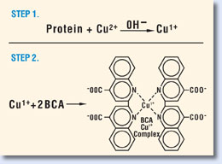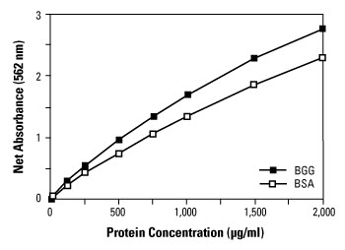
The BCA Protein Assay combines the reduction of Cu²⁺ to Cu¹⁺ by protein in an alkaline medium with the highly sensitive and selective colorimetric detection of the cuprous cation (Cu¹⁺) by bicinchoninic acid. The chelation of copper with protein in an alkaline environment forms a light blue complex (the biuret reaction), peptides containing three or more amino acid residues form a colored chelate complex with cupric ions in an alkaline environment containing sodium potassium tartrate. BCA reacts with the reduced (cuprous) cation. The intense purple-colored reaction product results from the chelation of two molecules of BCA with one cuprous ion. The BCA/copper complex is water-soluble and exhibits a strong linear absorbance at 562 nm with increasing protein concentrations. The BCA reagent is approximately 100 times more sensitive (lower limit of detection) than the pale blue color of the first reaction. The reaction that leads to BCA color formation is strongly influenced by four amino acid residues (cysteine or cystine, tyrosine, and tryptophan) in the amino acid sequence of the protein. However, unlike the Coomassie dye-binding methods, the universal peptide backbone also contributes to color formation, helping to minimize variability caused by protein compositional differences.

Protein quantification:
- Transfer 75μl/well of protein samples to 96well flat-bottom plate with 8 channel pipette.
- Add 75μl/well of WR to samples with the reserver.
- Incubate for 1hour at 60 degrees, sealing it and wrapping it with parafilm and aluminum foil.
- Centrifuge it for a few seconds.
- Measure the absorbance at 562nm on a plate reader to remove the lid and seal.
- Quantitate the samples with SpectraMAX250 (Wako).
Boot the display.
Place the plate on the Sample Tray.
Open[SOFT MAX PRO].
Click on [Set up].
L1:562nm
Mode: Endpoint
Click on[Template].
 | 1 | 2 | 3 | 4
A | Sta01 | Unk01 | Unk02 | Unk03
B | Sta02 | Unk01 | Unk02 | Unk03
C | Sta03 | Unk01 | Unk02 | Unk03
D | Sta04 | Unk01 | Unk02 | Unk03
E | Sta05 | Unk01 | Unk02 | Unk03
F | Sta06 | Unk01 | Unk02 | Unk03
G | Sta07 | Unk01 | Unk02 | Unk03
H | Sta08 | Unk01 | Unk02 | Unk03

1 Group: Standard
2 Group: Unknown
Click on [Series].
Starting value : 0.1
Step by / 2
Sta01: 0.1 Sta02: 0.05 Sta03:0.025 Sta04:0.0125 Sta05:0.00625
Sta06:0.003125 Sta07:0.0015625 Sta08:0.00078125
Click [Read] two times to mix the samples.
Save: Command + S
Print: Command + P
- Calculate composition (Protein suspension(average value), PBS and 5×loading buffer containing 20mM DTT, total 15μl) in the loading sample. Adjust to 10〜40μg of protein.
Ex. Dilution rate:E 16×10×2=320 F 32×10×2=640 G64×10×2=1280
E 0.035μg/μl×320=11.2
F0.018×640=11.5
G0.008×1280=10.2
Average: 11μg
Sample3.64μl（40μg）＋PBS8.36μl＋5×sample loading buffer3μl=total15μl
×10 Sample36.4μl＋PBS73.6μl＋5×sample loading buffer40μl
- Add 5×sample buffer containing 200mM DTT into the samples.
- Boil them for 5min at 100℃ with cap, switch off and cool down for 10min to denature the proteins and place it on ice.
- Centrifuge it at 15,000rpm for 2min with a cap.
- Store them at－20℃.

Electrophoresis:
1×SDS-PAGE Running buffer:
Tris 15.1g(final conc.25mM)
Glysine 94g(final conc.250mM)
SDS 5g(final conc.1%)
MilliQ up to 5L

- Assemble the glass plates, a rubber and a comb. Wipe the plates using KimWipe soaked with 70% ethanol and DDW. Check for leaks with 70%Ethanol. Pull the rubber to seal them. Mark the line at the location of 1cm below the loading point with marker.
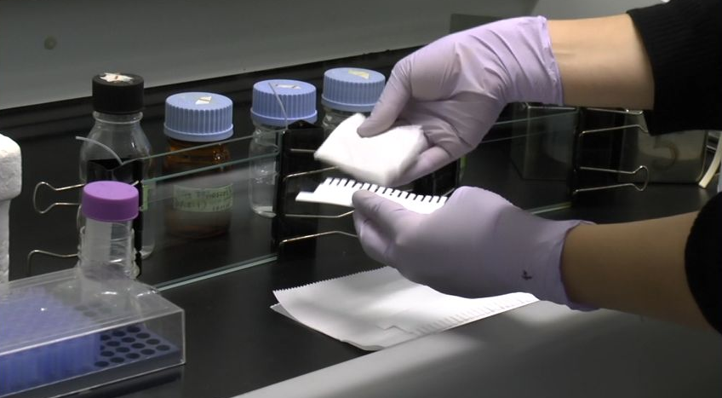
- Determine the volume of the gel mold. In an erlenmeyer flask or disposable plastic tube, prepare an appropriate volume of solution containing the desired concentration of acrylamide for the resolving gel, using the values given in Table.

8%gel: Separation capacity of 8% gel is higher than 10% gel.
Components | 10ml(1gel) | 20ml(2gel)
MilliQ | 4.6ml | 9.3ml
Acrylamide mix(30%) | 2.7ml | 5.3ml
Tris(1.5M, pH8.8) | 2.5ml | 5.0ml
SDS(10%) | 0.1ml | 0.2ml
Ammonium persulfate(APS)(10%)  (Polymerization accelerator) | 0.1ml | 0.2ml
TEMED  (Polumerization initiator) | 0.006ml | 0.012ml
10%gel:
Components | 10ml(1gel) | 20ml(2gel)
MilliQ | 4.0ml | 8.0ml
Acrylamide mix(30%) | 3.3ml | 6.7ml
Tris(1.5M, pH8.8) | 2.5ml | 5.0ml
SDS(10%) | 0.1ml | 0.2ml
APS(10%) | 0.1ml | 0.2ml
TEMED | 0.004ml | 0.008ml
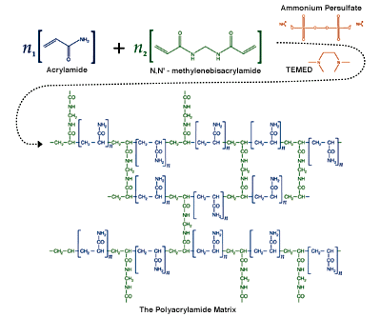
Mix the components in the order shown. Rapid polymerization will begin as soon as the TEMED has been added. Without delay, vortex the mixture and place it for few minutes to remove bubbles.
- Pour the solution into the gap between the glass plates of the electrophoresis apparatus, leaving sufficient space for the stacking gel (the length of the teeth of the comb plus 1cm). Use a Pasteur pipette to carefully overlay DDW (or1-butanol or isopropanol). Tap it to remove bubbles. Place the gel in a vertical position at RT for 30min～ several hours or at －4℃(wrapped with wet Kimwipe Sran wrap for several weeks.)
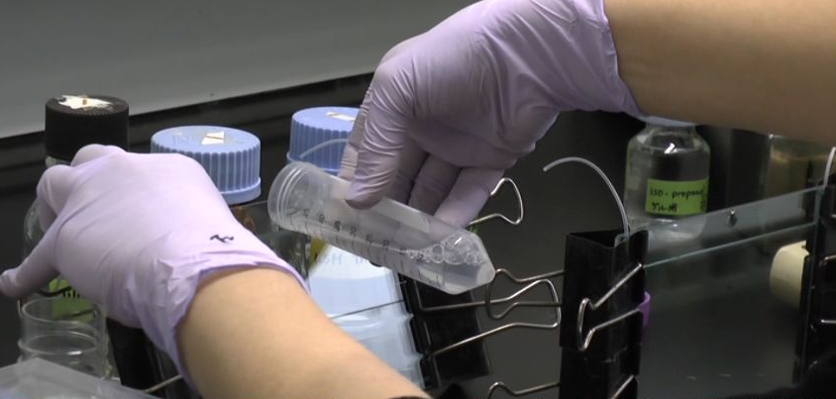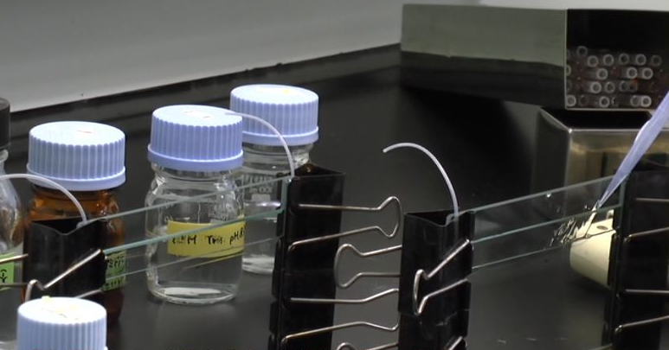
- After polymerization is complete, (pour off the overlay and wash the top of the gel several times with deionized H₂O to remove unpolymerized acrylamide). Drain as much fluid as possible from the top of the gel, and then remove any remaining H₂O with the edge of a paper towel.
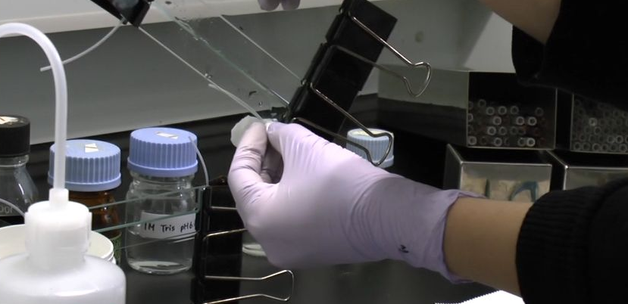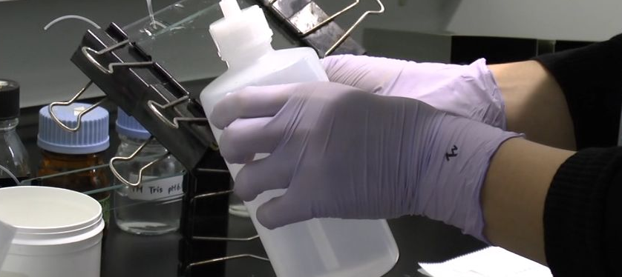
- In a disposable plastic tube, prepare the appropriate volume of the stacking gel mixture using the values given. Mix the components in the order shown. Polymerization will begin as soon as the TEMED has been added. Without delay, vortex the mixture.
- Pour or pipette the stacking gel mix to fill the space above the resolving gel. Immediately insert a clean comb into the stacking gel solution, taking care to avoid trapping air babbles. Add more stacking gel solution as needed to fill the spaces of the comb completely. Place the gel in a vertical position at RT for 30min ～ several hours or at －4℃(wrapped with wet Kimwipe and Sran wrap for several weeks.)
Components | 2ml(1gel) | 4ml(2gel)
MilliQ | 1.4ml | 2.7ml
Acrylamide mix(30%) | 0.33ml | 0.67ml
Tris(1.5M, pH6.8) | 0.25ml | 0.5ml
SDS(10%) | 0.02ml | 0.04ml
APS(10%) | 0.02ml | 0.04ml
TEMED | 0.002ml | 0.004ml
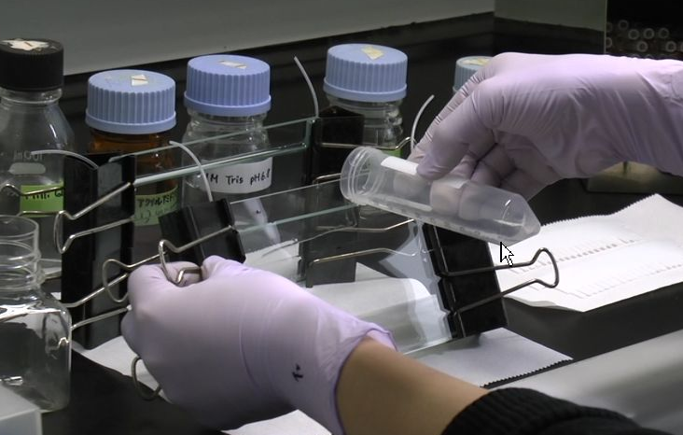
- As the stacking gel’s polymerization is complete (30min), carefully remove the comb. Use a squirt bottle to wash the wells immediately with DDW to remove umpolymerized acrylamide. If necessary, straighten the teeth of the stacking gel with a blunt hypodermic needle attached to a syringe.
- Mount two gels or (a gel and false container) in the electrophoresis apparatus. Add Tris-glycine electrophoresis buffer (1×SDS-PAGE Running buffer) at the bottom of apparatus and at the bottom of gel between the glass plate. Remove the babbles at the bottom. Wash the wells with syringe. At with first only air, and next with buffer.
- Press [CC]. Electrophorese the apparatus at 30mA for 30 min to stabilize the gels.
- Incubate samples and a protein marker (Protein Plus Protein Standard(Bio Rad)) at 55℃ for 5 min. to dissolve SDS.
- Wash the wells with air of syringe and wash the wells with buffer of syringe.
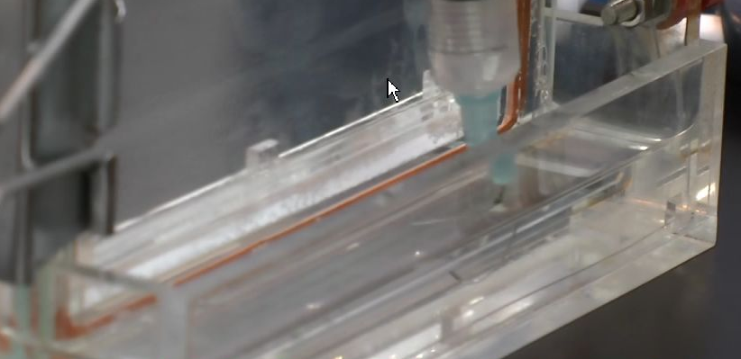
- Load 5μl of the protein marker into the first wall. Load 15μl of the samples into the bottoms of the walls. Load 15μl of the 1×loading buffer into remaining wells. Stand walls of wells with syringe.
- Attach the electrophoresis apparatus to an electric power supply. Apply electrical current to the gel at 15mA per one gel up to the edge of stacking gel for 20min, observing. Add the buffer up to the top of gels.
※Had better electrophorese samples with one gel and slowly at a low current to avoid rise in temperature.
- Apply electrical current to the gel at 15mA per one gel for several hours.
- Remove the gel sandwich from the apparatus.

Transfer:
Immobilion-P (Millipore) :Adjust the size of the gel.
Filter paper (ADVANTEC) Grade 26 9 cm×9 cm
Transfer buffer:
Tris 36.42g (final conc. 100mM)
Glycine 43.23g (final conc.192mM)
MilliQ diluting in measuring cylinder to 3L total

- Immerse 4 filter paper into transfer buffer(1×blotting buffer(Semi-dry)) . ※Do not shake it.
- Immerse PVDF(polyvinylidene difluoride) membrane into methanol for 5 min (more than 20 sec) to augment hydrophilia.
- Soak PVDF membrane in transfer buffer shaking for 10min.
- Remove the stacking gel and extra gels using medicine spoon. Place the pouring face of the gel to a downward direction.

- Soak the gel into transfer buffer shaking for 15min to remove SDS in loading buffer.
- Place two filter papers on the semi-dry transfer apparatus. Remove the bubbles with filter or medicine spoon. Pour low the transfer buffer.
- Place PVDF membrane. Pour low the transfer buffer. Note: Do not dry the membrane.
- Place gel. Pour low the transfer buffer.
- Place two filter papers.
- Roll 3ml eiken tube on them to remove babbles.
- Remove the excess water around.
- Apply a voltage of 12V/cm and 1.5mA/cm² to them for a hour.
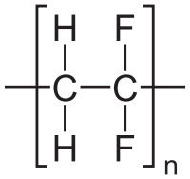 PVDF(polyvinylidene difluoride)
Trouble shooting:
These are lacking in cohesion.

0.1%Ponceau Solution:
Acetic acid 2.5ml(5%)
Ponceau S 50mg(0.1%)
DDW up to 50ml
- Add 1ml of Ponceau S on the membrane and wash the membrane using tap water.
- Immerse the membrane into TBST for 5min.
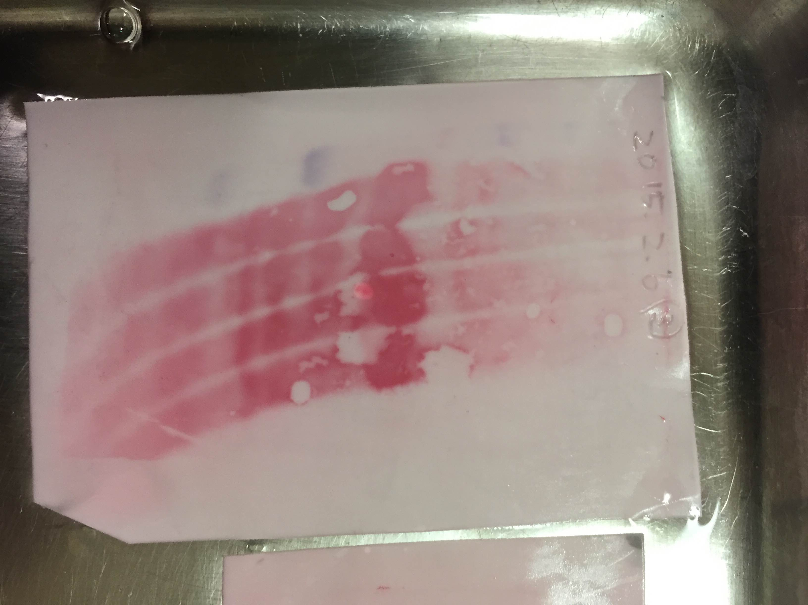
Trouble shooting:
Smiling and spots are seen.
Smiling is due to a difference in mobility of samples.
Cause for smiling:
A rise in temperature with increasing current.
Loading sample volumes of all wells are not equivalent.
Some spots are resulting from lacking in cohesion during transfer.

Antigen-antibody reaction: with Can get signal(TOYOBO)
2%Skim milk:
Skim milk 1g
PBST or TBST 50ml

PBST or TBST(If anti-phosphorylation antibody is used):
0.1%Tween20 0.5ml(final conc. 0.1%)
×20 PBS(－) or TBS 25ml
DDW up to 500ml

- Check and see pre-stain marker the lane of protein. If the marker is pale, mark the pre-stain marker with permanent marker. Write the date on the top of the membrane. Cut the edge to recognize the membrane.
- Wash the membrane shaking in PBS for 10 min.
- Immerse the membrane into methanol for 1 min.
- Wash the membrane shaking in PBST for 10 min.
- Blocking : Seal the membrane with heat film(yamamoto) using heat sealer(FUJI IMPRESS). Pour 2.5ml of the blocking solution (skim milk or BSA etc) into the bag and incubate for 1～1.5 hours at RT or at 4℃ overnight. Or (Immerse the membrane with Blocking one-P (Nacalai tesque; if anti-phosphorylation antibody is used.) for 20 min at RT.
- Primary antibody reaction:Dilute the antibody with Blocking Solution. Seal the membrane with heat film(yamamoto) using heat sealer(FUJI IMPRESS). Pour 2ml of primary solution on the protein surface in the bag and incubate it shaking slowly at RT for 1 hour or 4℃ overnight. Remove air bubbles in the membrane with a rub of the fingers.
- Wash it 3 times shaking with TBST for 10 min at different container.
- Secondary antiobody reaction: Dilute the antibody with blocking solution. Seal the membrane with heat film(yamamoto) using heat sealer. Pour 1ml of secondary solution on the protein surface in the bag and incubate it at RT for 1 hour or 4℃ overnight. Remove air bubbles in the membrane with a rub of the fingers.
- Wash it 2 times with TBST and once with TBS shaking for 10 min at about 50rpm to remove non-specific band.
- Move to dark room upatairs and switch the automatic film developer on.
- Mix ECL(or ECL prime) reagent 1 and 2 at the rate of 1:1 in Eiken tube and pipette it up and down.
- Wipe a rectangular plastic dish with kimewipe immersed in 70%ethnol.
- Drop 1ml of the mixture per a membrane on the membrane in the rectangular dish.
- Incubate it at RT for 5 min.
- Put the membrane into a mount wrapped with Saran Wrap and place it into film cassette and fix it with a tape and wrap the unit with Saran rap.
- Move to dark room upatairs, and place a film on the membrane and close the film cassette in the dark.
- Expose the membrane to X-ray film for 30s, 1 min, 3min or 5min.
- If it has a high sensitivity using ECL prime, wash the membrane with PBS and drop 1ml ECL of the mixture per a membrane and incubate it at RT for 5 min.
- Put the film into the internal entrance of developing machine in the dark. ※When alarm go off, next film can be put into the internal entrance of developing machine and be able to switch on the light.
- Mark the pre-stain marker of film with a pen comparing to the membrane.
- Immerse the membrane into WB stripping solution(nacalai tesque) for 15 min〜1 hour at RT in order to remove antibody. ※Put gloves on to protect your skin.
- Wash it with PBST of TBST for 5 min at about 50 rpm.
- It can be stored in TBST at −4℃(Restart from Step 5) or in a dry form at RT (Restart from Step 3.).

Primary antibody:
C/EBPβ(C-19)：sc-150 Rabbit polyclonal antibody (Rate:1:1000〜2000)
C/EBPβ(H-7)：sc-7962 Mouse monoclonal antibody (Rate:1:1000)
GAPDH(14C10) Rabbit mAb #2118 Rabbit polyclonal antibody (Rate:1:1000〜2000)

Secondary antibody:
Anti-rabbit HRP : 1:5000 −20℃
Anti-mouse HRP : 1:5000 −20℃

