Western blotting of transfectioned cells

Preparation of Whole Cell Lysate
Cell count/10cm dish:
- Harvest cells into 1.5ml Eppendorf tube.
- Add 1ml of PBS into the cells and suspend them.
- Centrifuge at 4000rpm, 4℃ for 1min.
- Remove the supernatant.
- Prepare RIPA lysis buffer described as below.
- Resuspend cells in 100〜200μl of RIPA lysis buffer.
- Incubate them on ice for 30 min and vortex every 10 min.
- Centrifuge them at 15000rpm, 4℃ for 15min.
- Transfer 90μl of the supernatant to clean 1.5ml eppendorf tube.※It can be stored at −90℃.
- Take 30μl of the supernatant into a new 1.5ml Eppendorf tube for determination quantity.

RIPA lysis solution:
- Stock solution:
1M HEPES(pH7.9) | 3.5ml | 7.0ml | 13.65ml | 27.3ml | 54.25ml | 82.25ml
5M NaCl | 2.1ml | 4.2ml | 8.19ml | 16.38ml | 32.55ml | 49.35ml
10% TritonX-100 | 7.0ml | 14.0ml | 24.5ml | 54.6ml | 108.5ml | 164.5ml
500mM EDTA | 140μl | 280μl | 490μl | 1092μl | 2.17ml | 3.29ml
Total volume | 12.74ml | 25.48ml | 46.83ml | 99.372ml | 197.47ml | 299.39ml

- Final preparation before use:
Stock solution | 182μl | 910μl | 1.82ml | 9.1ml | 18.2ml | 36.4ml
100mM PMSF | 10.0 | 50.0μl | 100μl | 500μl | 1000μl | 2.0ml
0.5mg/ml Pepstatine | 2.0 | 10.0μl | 20.0μl | 100μl | 200μl | 400μl
10mg/ml Leupeptin | 1.0 | 5.0μl | 10.0μl | 50.0μl | 100μl | 200μl
5mg/ml Aprotinine | 2.0 | 10.0μl | 20.0μl | 100μl | 200μl | 400μl
Phosphatase inhibitor | 10.0 | 50.0μl | 100μl | 500μl | 1000μl | 2.0ml
DDW | 793μl | 3.965ml | 7.93ml | 39.65ml | 79.3ml | 158.5ml
Total volume | 1.0ml | 5.0ml | 10.0ml | 50.0ml | 100ml | 200ml
PMSF: serine protease
Pepstatine: Aspartate protease
Leupeptin: serine protease, cysteine protease
Aprotine: cysteine protease
Stored at —20℃.
Phosphatase inhibitor cocktail (EDTA free) (nacalai tesque) Stored at –４℃.

Takara BCA Protein Assay Kit(T9300A).
Standard serial dilution (with 0.1% BSA):
BSA(µl) | 1×PBS | Final conc.(µg/ml)
120μl | 0 | 2,000
90μl | 30 | 1,500
60μl | 60 | 1,000
45μl | 75 | 750
30μl | 90 | 500
15μl | 105 | 250
10μl | 150 | 125
0μl | 120 | 0 (Blank)
BCA: bicinchoninic acid
Pipette these solution 10 times every well.
Reaction solution:
BSA or sample 10µl
WS 200µl
Incubate them at 37℃ for 30min. and after then, place them at RT.

Serial dilution:
 | 1/10 | 1/20 | 1/40 | 1/80 | 1/160 | 1/320 | 1/640 | 1/1280
Sample(µl) | 6 | 30 | 30 | 30 | 30 | 30 | 30 | 30
1×PBS | 54 | 30 | 30 | 30 | 30 | 30 | 30 | 30
Total | 60 | 60 | 60 | 60 | 60 | 60 | 60 | 60
Remain | 30 | 30 | 30 | 30 | 30 | 30 | 30 | 60
Mix the above reagents in an Eiken tube .
Tramsfer the Master mix into a reserver.
Principle:
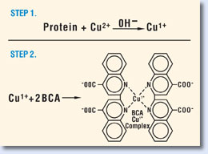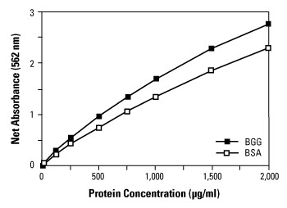
The BCA Protein Assay combines the reduction of Cu²⁺ to Cu¹⁺ by protein in an alkaline medium with the highly sensitive and selective colorimetric detection of the cuprous cation (Cu¹⁺) by bicinchoninic acid. The chelation of copper with protein in an alkaline environment forms a light blue complex (the biuret reaction), peptides containing three or more amino acid residues form a colored chelate complex with cupric ions in an alkaline environment containing sodium potassium tartrate. BCA reacts with the reduced (cuprous) cation. The intense purple-colored reaction product results from the chelation of two molecules of BCA with one cuprous ion. The BCA/copper complex is water-soluble and exhibits a strong linear absorbance at 562 nm with increasing protein concentrations. The BCA reagent is approximately 100 times more sensitive (lower limit of detection) than the pale blue color of the first reaction. The reaction that leads to BCA color formation is strongly influenced by four amino acid residues (cysteine or cystine, tyrosine, and tryptophan) in the amino acid sequence of the protein. However, unlike the Coomassie dye-binding methods, the universal peptide backbone also contributes to color formation, helping to minimize variability caused by protein compositional differences.

Protein quantification:
- Add 2×sample buffer (Ez Apply) and PBS(－) into the samples.
- Boil them for 5min at 100℃. with cap switch off and cool down for 10min to denature the proteins and place it on ice.
- Centrifuge it at 15,000rpm for 2min with a cap.
- Store them at－20℃.

Electrophoresis:
- Mount two gels or (a gel and false container) in the electrophoresis apparatus. Add Tris-glycine electrophoresis buffer (1×SDS-PAGE Running buffer) at the bottom of apparatus and at the bottom of gel between the glass plate. Remove the babbles at the bottom. Wash the wells with syringe. At with first only air, and next with buffer.
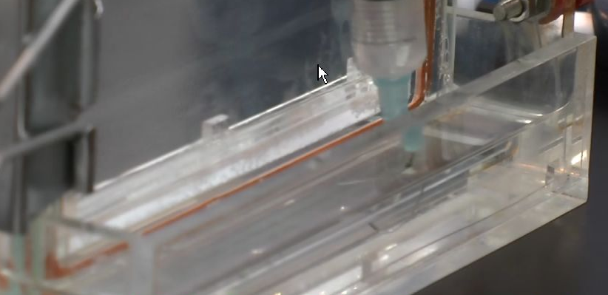
- Load 3μl of molecular weight marker for SDS-PAGE into the first wall. Load 15μl of the samples into the bottoms of the walls. Load 15μl of the 1×loading buffer into remaining wells. Stand walls of wells with syringe.
- Attach the electrophoresis apparatus to an electric power supply. Apply electrical current to the gel at 15mA per one gel up to the edge of stacking gel for 20min, observing. Add the buffer up to the top of gels.
※Had better electrophorese samples with one gel and slowly at a low current to avoid rise in temperature.
- Apply electrical current to the gel at 20mA per one gel for 80 min..
- Remove the gel sandwich from the apparatus.

Transfer:
Immobilion-P (Millipore) :Adjust the size of the gel.
Filter paper (ADVANTEC) Grade 26 9 cm×9 cm
Transfer buffer: EzBlot (ATTO)
 | Chief component
Blotting buffer A | Tris
Blotting buffer B | Tris
Blotting buffer C | Tris, aminocaproic acid

Tris 36.42g (final conc. 100mM)
Glycine 43.23g (final conc.192mM)
MilliQ diluting in measuring cylinder to 3L total

- Immerse PVDF(polyvinylidene difluoride) membrane into methanol for 10 sec to augment hydrophilia.
- Soak PVDF membrane in 50ml of Blotting buffer B shaking for 30min.
- Remove the stacking gel and extra gels using medicine spoon. Place the pouring face of the gel to a downward direction.

- Soak the gel into Blotting buffer B shaking.
- Soak two filter papers into 50ml of Blotting buffer A, a filter paper into 50ml Blotting buffer B and 3 filter papers into 50ml of Blotting buffer C. Remove the bubbles with filter or medicine spoon. Pour low the transfer buffer.
- Place two filter papers (soaked in A Solution), a filter paper (soaked in B solution), PVDF membrane, the gel and three filter papers from the bottome on the semi-dry transfer apparatus. Remove babbles with a filter. Note: Place the gel with film. Do not dry the membrane.
- Roll 3ml eiken tube on them to remove babbles.
- Apply a current of 2mA/cm² to them for 30～60min.
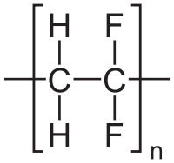 PVDF(polyvinylidene difluoride)
Trouble shooting:
These are lacking in cohesion.

0.1%Ponceau Solution:
Acetic acid 2.5ml(5%)
Ponceau S 50mg(0.1%)
DDW up to 50ml
- Add 1ml of Ponceau S on the membrane and wash the membrane using tap water.
- Immerse the membrane into TBST for 5min.
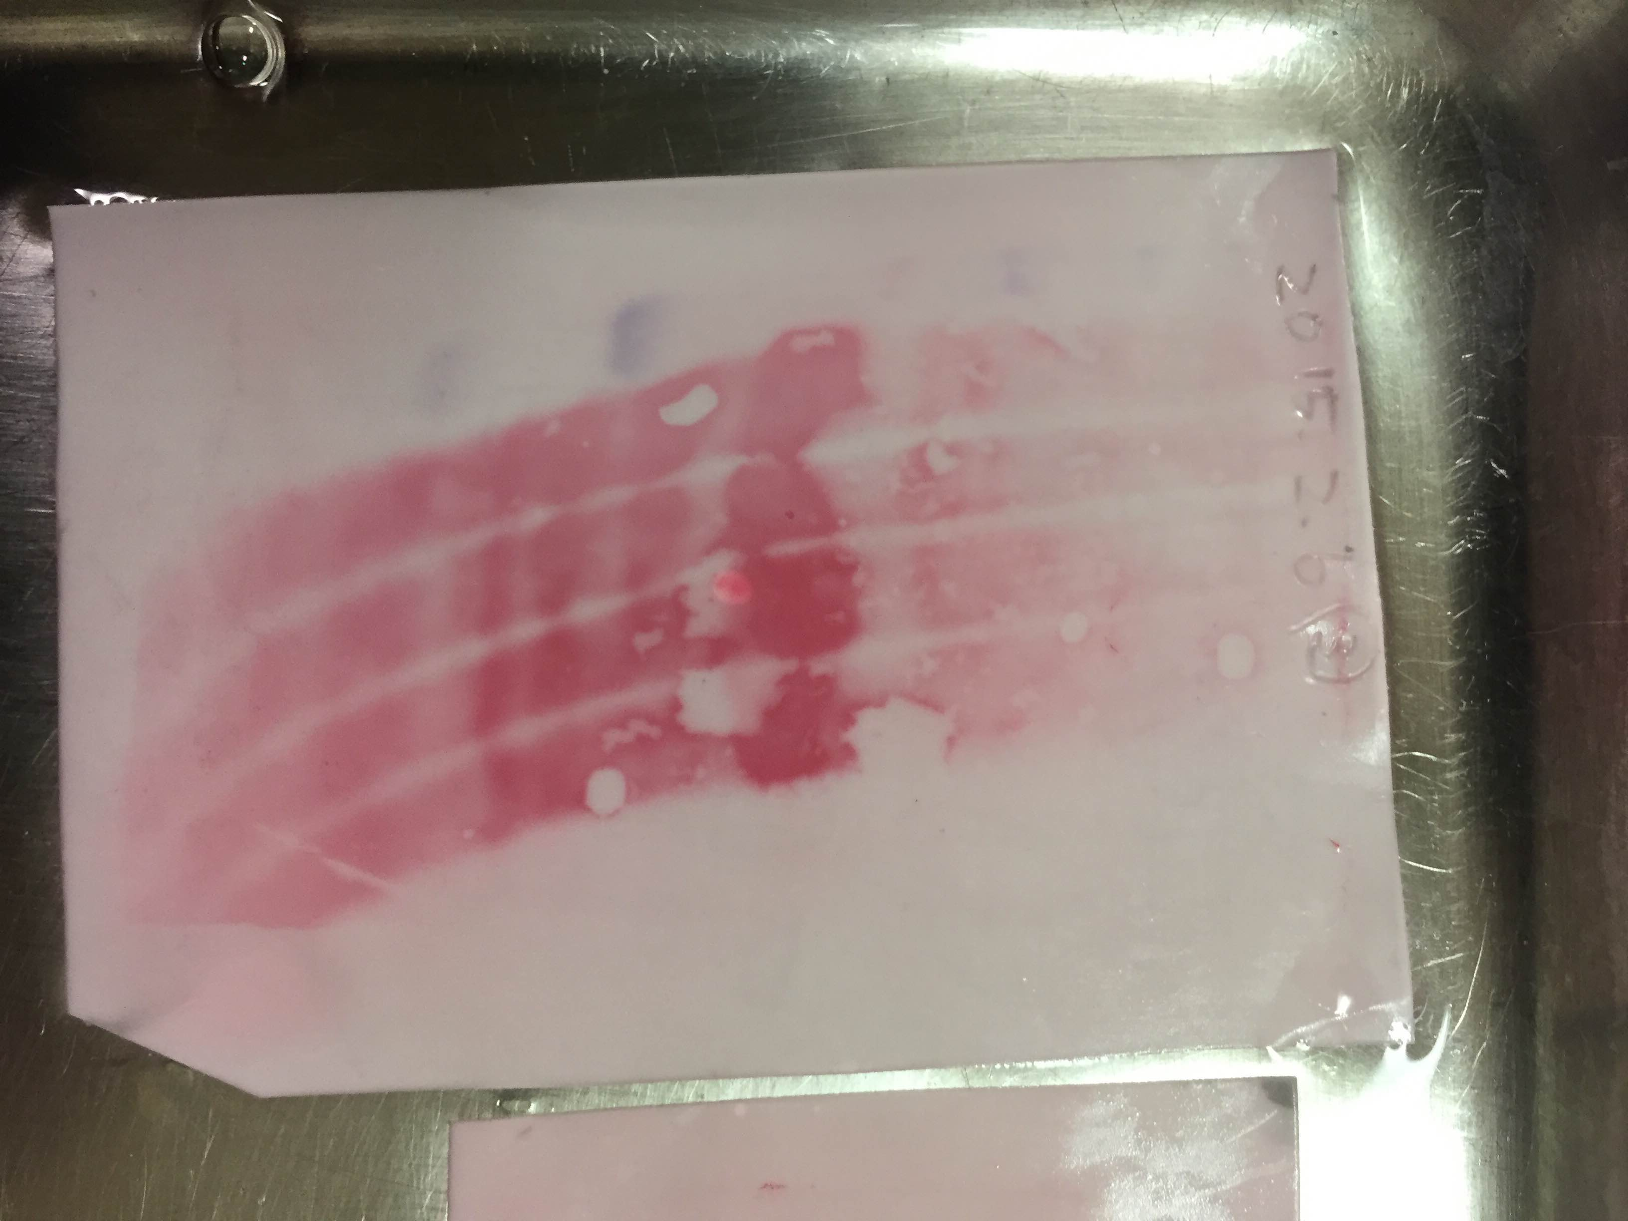
Trouble shooting:
Smiling and spots are seen.
Smiling is due to a difference in mobility of samples.
Cause for smiling:
A rise in temperature with increasing current.
Loading sample volumes of all wells are not equivalent.
Some spots are resulting from lacking in cohesion during transfer.

Antigen-antibody reaction: with Can get signal(TOYOBO)
2%Skim milk:
Skim milk 1g
PBST or TBST 50ml

PBST or TBST(If anti-phosphorylation antibody is used):
0.1%Tween20 0.5ml(final conc. 0.1%)
×20 PBS(－) or TBS 25ml
DDW up to 500ml

- Check and see pre-stain marker the lane of protein. If the marker is pale, mark the pre-stain marker with permanent marker. Write the date on the top of the membrane. Cut the edge to recognize the membrane.
- Wash the membrane shaking in PBS for 10 min.
- Immerse the membrane into methanol for 1 min. ※The methanol is reusable.
- Wash the membrane shaking in PBST for 10 min.
- Blocking : Seal the membrane with heat film(yamamoto) using heat sealer(FUJI IMPRESS). Pour 2.5ml of the blocking solution (skim milk or BSA etc) into the bag and incubate for 1～1.5 hours at RT or at 4℃ overnight. Or (Immerse the membrane with Blocking one-P (Nacalai tesque; if anti-phosphorylation antibody is used.) for 20 min at RT.
- Primary antibody reaction:Dilute the antibody with Blocking Solution. Seal the membrane with heat film(yamamoto) using heat sealer(FUJI IMPRESS). Pour 2ml of primary solution on the protein surface in the bag and incubate it shaking slowly at RT for 1 hour or 4℃ overnight. Remove air bubbles in the membrane with a rub of the fingers. ※The primaly antibody is reusable. It can be stored in the Eppendorf.
- Wash it 3 times shaking with TBST for 10 min (or a few seconds) at different container.
- Secondary antiobody reaction: Dilute the antibody with blocking solution. Seal the membrane with heat film(yamamoto) using heat sealer. Pour 1ml of secondary solution on the protein surface in the bag and incubate it at RT for 1 hour or 4℃ overnight. Remove air bubbles in the membrane with a rub of the fingers.
- Wash it 2 times with TBST and once with TBS shaking for 10 min (or a few seconds) at about 50rpm to remove non-specific band.
- Add 1ml of Ez West Blue (ATTO) on the membrane and place it for 5 min ～ 15 min.
- Wash the membrane using milliQ.
- Seal the membrane with heat film(yamamoto) blocking out light. Scan the image immediately.
- Mark the pre-stain marker of film with a pen comparing to the membrane.
- Immerse the membrane into WB stripping solution(nacalai tesque) for 15 min〜1 hour at RT in order to remove antibody. ※Put gloves on to protect your skin.
- Wash it with PBST of TBST for 5 min at about 50 rpm.
- It can be stored in TBST at −4℃(Restart from Step 5) or in a dry form at RT (Restart from Step 3.).

Primary antibody:
C/EBPβ(C-19)：sc-150 Rabbit polyclonal antibody (Rate:1:1000〜2000)
C/EBPβ(H-7)：sc-7962 Mouse monoclonal antibody (Rate:1:1000)
GAPDH(14C10) Rabbit mAb #2118 Rabbit polyclonal antibody (Rate:1:1000〜2000)

Secondary antibody:
Anti-rabbit HRP : 1:5000 −20℃
Anti-mouse HRP : 1:5000 −20℃

