Supplementary information
Loss of Stemness, EMT and Supernumerary Tooth Formation in Cebpb^{-/-}Runx2^{+/-} Murine Incisors

Kazuyuki Saito^{1,5}, Katsu Takahashi^{1,✴}, Boyen Huang², Masakazu Asahara³, Honoka Kiso¹, Yumiko Togo¹, Hiroko Tsukamoto¹, Sayaka Mishima¹, Masaki Nagata⁴, Machiko Iida⁵, Yoshihito Tokita⁵, Masato Asai⁵, Akira Shimizu⁶, Toshihisa Komori⁷, Hidemitsu Harada⁸, Mary MacDougall⁹, Manabu Sugai^{10,✴}, Kazuhisa Bessho¹

¹Department of Oral and Maxillofacial Surgery, Graduate School of Medicine, Kyoto University, Kyoto, Japan
²Professor of Dentistry and Head of School, School of Dentistry and Health Sciences, Faculty of Science, Charles Sturt University, Leeds Parade Orange NSW 2800 Australia
³Division of Liberal Arts and Sciences, Aichi Gakuin University, Aichi, Japan
Department of Oral and
Maxillofacial Surgery, Niigata University Graduate School of Medical
and Dental Sciences, 2-5274 Gakkocho-dori, Niigata 951-8514, Japan
Department of Oral and
Maxillofacial Surgery, Niigata University Graduate School of Medical
and Dental Sciences, 2-5274 Gakkocho-dori, Niigata 951-8514, Japan
⁴Department of Oral and Maxillofacial Surgery Niigata University Graduate School of Medical and Dental Sciences, Niigata, Japan
⁵Department of Perinatology, Institute for Developmental Research, Aichi Human Service Center, Kasugai, Aichi, Japan
⁶Department of Experimental Therapeutics, Institute for Advancement of Clinical and Translational Science, Kyoto University Hospital, Kyoto, Japan
⁷Department of Cell Biology, Unit of Basic Medical Sciences, Nagasaki University Graduate School of Biomedical Sciences, Nagasaki, Japan
⁸The Advanced Oral Health Science Research Center, Iwate Medical University, Iwate, Japan.
⁹Institute of Oral Health Research & Department of Oral and Maxillofacial Surgery, School of Dentistry, University of Alabama, Birmingham, Alabama, United States of America
¹⁰Department of Molecular Genetics, Division of Medicine, Faculty of Medical Sciences, University of Fukui, Fukui, Japan

✳Corresponding author:

Dr. Manabu Sugai, Department of Molecular Genetics, Division of Medicine, Faculty of Medical Sciences, University of Fukui, Fukui, Japan. Tel.: +81-0776-61-8312, Fax: +81-0776-61-8164, E-mail: msugai@u-fukui.ac.jp

Dr. Katsu Takahashi, Department of Oral and Maxillofacial Surgery, Graduate School of Medicine, Kyoto University
Shogoin-Kawahara-cho 54, Sakyo-ku, Kyoto 606-8507, Japan. Tel.: +81-75-751-3403, Fax: +81-75-761-9732, E-mail: takahask@kuhp.kyoto-u.ac.jp

Supplementary information

The PDF file includes:
Supplementary Figure 1, 2, 3, 4, 5, 6 and table 1, 2

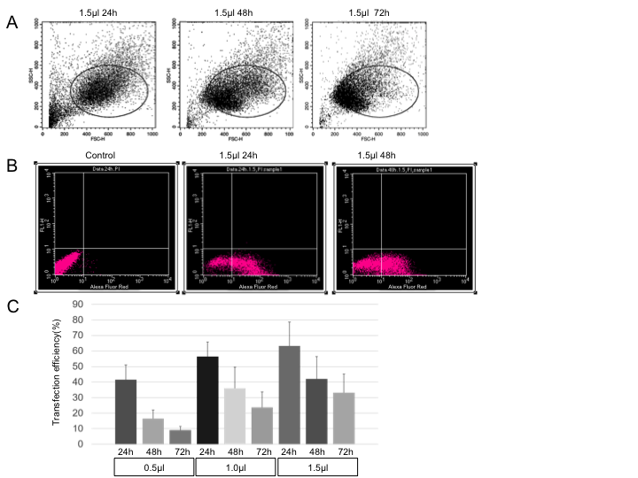

Supplementary Figure 1 | Transfection efficiency of mHAT9d cells with stealth siRNA.
Efficiency was measured by fluorescence-activated cell sorting (FACS caliber; BD, NJ, USA) 24, 48, and 72 h after transfection of BLOCK-iT (TM) Alexa Fluor (R) Red Fluorescent Control (Thermo Fisher Scientific, Waltham, MA, USA).
A: Gated dot plots generated by Cell QuestTM Pro Software (BD) indicate forward scatter (X-axis) and side scatter (Y-axis) following transfection with 1.5 μL Lipofectamine® RNAiMAX (Thermo Fisher Scientific).
B: Comparison between control (without transfection), 24h and 48h after transfection with 1.5 μL Lipofectamine® RNAiMAX. Gated dot plots generated by Cell QuestTM Pro Software indicate Alexa Fluor Red (X-axis) and FL-1H (Y-axis)).
C: Efficiency is represented as mean ± standard deviation following transfection with 0.5, 1.0, and 1.5 μL Lipofectamine® RNAiMAX. Number of samples is 4.

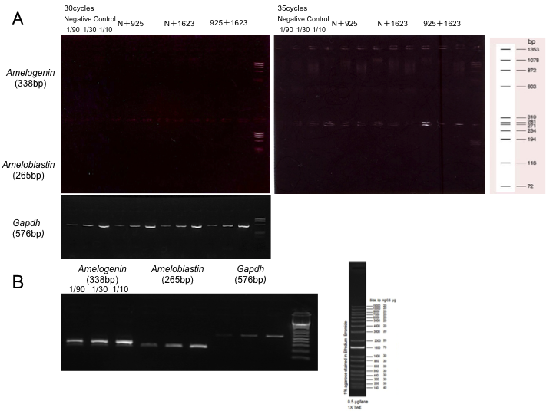

Supplementary Figure 2 | Semi-quantitative reverse transcription polymerase chain reaction (RT-PCR) of mHAT9d cells transfected with stealth siRNA for amelogenin (Amelx) and ameloblastin (Ambn).
A: Total RNA (3μg) was extracted from 70% confluent mHAT9d cells and reverse transcribed using a SuperScript ®IV First-Strand Synthesis System (Thermo Fisher Scientific, Waltham, Massachusetts, USA). The cDNAs were serially diluted and PCR amplification was performed using KOD FX (KFX-101, TOYOBO, Osaka, Japan) and specific oligonucleotide primers for Amelx, Ambn and glyceraldehyde 3-phosphate dehydrogenase (Gapdh) (Supplemental Table 1). No PCR products were detected in 30-35 cycles using a 2% agarose gel electrophoresis with φ×174-HaeⅢdigest (3405A, TaKaRa Bio, Shiga, Japan). N indicates negative control stealth siRNA; 925 and 1623 indicate Cebpb and Runx2 type1 siRNA, respectively (final concentration 20 nM). Each siRNA was the same in quantity (10 nM each) when mixed.
B: Total RNA (0.5µg) was extracted from labial cervical loop epitheliums in apical end of four bimaxillary incisors of a 129sv wild-type mouse and reverse transcribed as stated above. The cDNAs were serially diluted and PCR amplification was performed using KOD FX and specific oligonucleotide primers for Amelx, Ambn, and Gapdh. The PCR products were detected in 25 cycles using a 2% agarose gel electrophoresis with 1kb plus DNA Ladder (10787-018, ThermoFisher scientific).

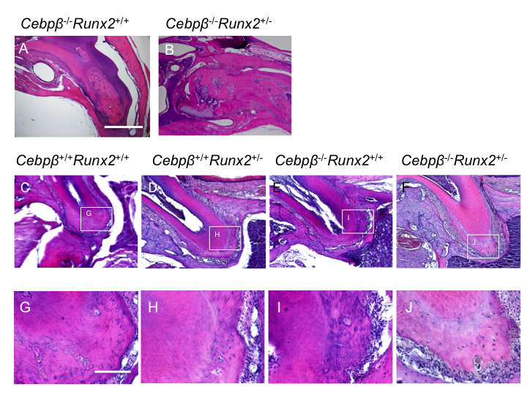

Supplementary Figure 3 | Hematoxylin-eosin (H&E) staining of cementum-like hard tissue in the dental pulp and cementum in adult maxillary molars in Cebpβ and/or Runx2 double genetically modified mice (F₂: 129Sv/C57BL/6) at 3 months after birth.

A, B: Cementum-like hard tissue of dental pulp in maxillary incisors in Cebpb^{-/-}Runx2^{+/+} or Cebpb^{-/-}Runx2^{+/-} mice. Scale bar: 1mm, 40×.

C-F: Root with cementum in mouse molar (M1)×100 Scale bar: 100 μm, 100×.

G-J: Higher magnification image of cellular intrinsic fiber cementum (CIFC). Scale bar: 100 μm, 400×.

C, D, G, H: Margin of CIFC is smooth shaped in wild-type or Runx2 heterozygnous mice.

E, F, I, J: Margin of CIFC is invasive type and rough-edged in Cebpb null mice.

Supplementary Figure 4 | the upper incisors of Cebpb^{+/+}Runx2^{+/-} and Cebpb^{-/-}Runx2^{+/-} F₂ mice (129Sv/C57BL/6) on day 7 after birth.

No supernumerary tooth formation of the incisors of both mice. Scale bar: 100μm.

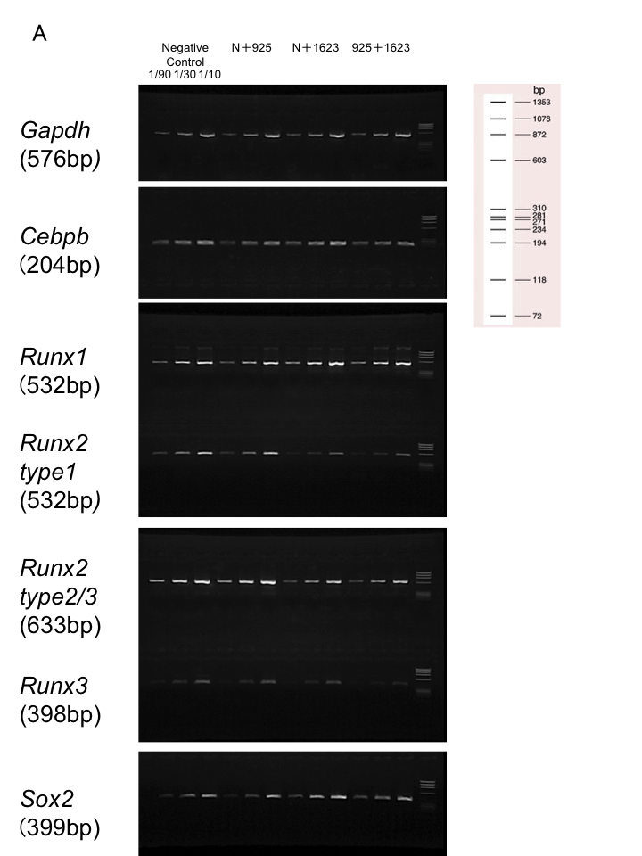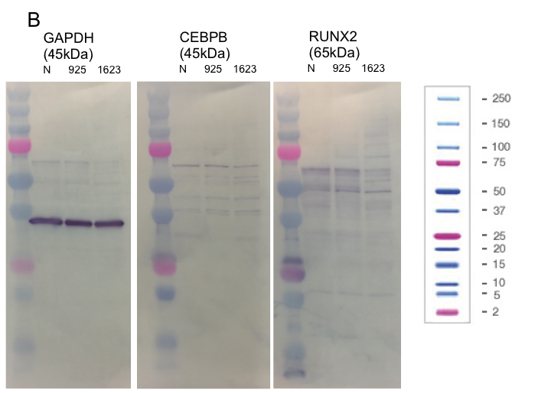
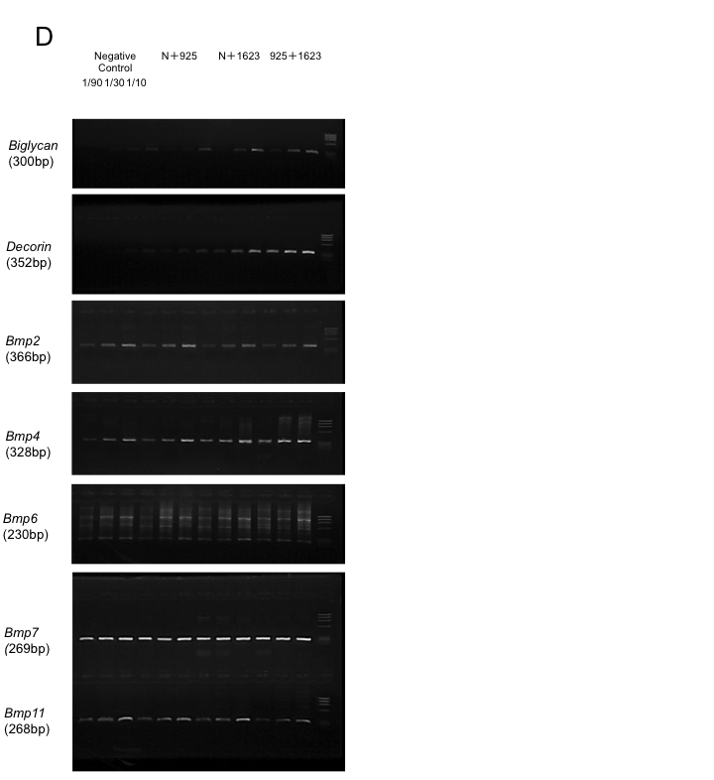
Supplementary Figure 5 |Full-length gels and blots in Figure 5.
A, C, D: Total RNA (3μg) was extracted from 70% confluent mHAT9d cells and reverse transcribed using a SuperScript ®IV First-Strand Synthesis System (Thermo Fisher Scientific, Waltham, Massachusetts, USA). The cDNAs were serially diluted and PCR amplification was performed using KOD FX (KFX-101, TOYOBO, Osaka, Japan) and specific oligonucleotide primers and glyceraldehyde 3-phosphate dehydrogenase (Gapdh) (Supplemental Table 1). PCR products were detected using a 2% agarose gel electrophoresis with φ×174-HaeⅢdigest (3405A, TaKaRa Bio, Shiga, Japan). N indicates negative control stealth siRNA; 925 and 1623 indicate Cebpb and Runx2 type1 siRNA, respectively (final concentration 20 nM). Each siRNA was the same in quantity (10 nM each) when mixed. B: Western blotting results.Western blotting of mHAT9d cells transfected with Cebpb and Runx2 type1 stealth siRNA was performed using the following antibodies: anti-Gapdh primary rabbit polyclonal (1:1000, sc-150; Santa Cruz Biotechnology), secondary anti-rabbit IgG (1:5000, #7074; Cell Signaling Technology), anti-C/EBP beta primary rabbit polyclonal (1:200, #3087; Cell Signaling Technology), anti-Runx2 primary rabbit polyclonal (1:200, M-70 and sc-10758; Santa Cruz Biotechnology), and secondary anti-rabbit IgG (1:1000, #7074; Cell Signaling Technology). Ez West Blue (AE-1490; ATTO, Tokyo, Japan) was used to stain the membranes and detect the proteins of interest.

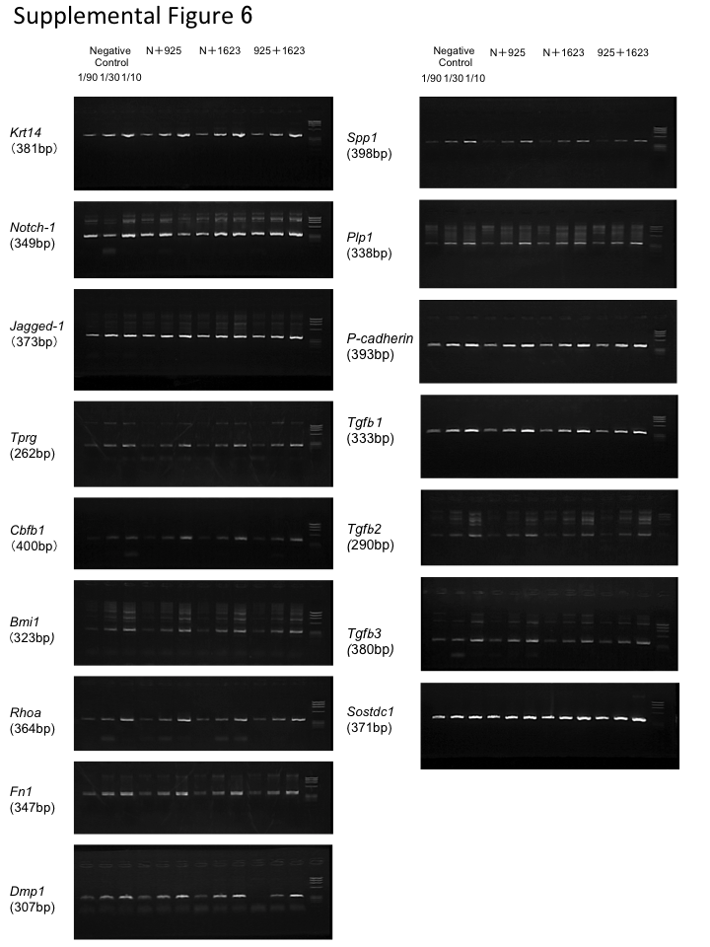

Supplementary Figure 6 | Semi-quantitative reverse transcription polymerase chain reaction (RT-PCR) of mHAT9d cells transfected with stealth siRNA for genes characteristic of them.
Total RNA was extracted from 70% confluent mHAT9d cells and reverse transcribed using a SuperScript ®IV First-Strand Synthesis System (Thermo Fisher Scientific, Waltham, Massachusetts, USA). The cDNAs were serially diluted and PCR amplification was performed using KOD FX (KFX-101, TOYOBO, Osaka, Japan) and specific oligonucleotide primers (Supplemental Table 2), and glyceraldehyde 3-phosphate dehydrogenase (Gapdh) (Supplemental Table 1). PCR products were detected using a 2% agarose gel electrophoresis with φ×174-HaeⅢdigest (3405A, TaKaRa Bio, Shiga, Japan). N indicates negative control stealth siRNA; 925 and 1623 indicate Cebpb and Runx2 type1 siRNA, respectively (final concentration 20 nM). Each siRNA was the same in quantity (10nM each) when mixed.

Gene name | Forward sequence | Reverse sequence | NCBI accession number
Gapdh | CCATCACCATCTTCCAGGAG | CCTGCTTCACCACCTTCTTG | NM_008084.3
Cebpb | ACACGTGTAACTGTCAGCCG | GCTCGAAACGGAAAAGGTTC | NM_001287738.1
Runx1 | AGAAGTGTAAGCCCAGCACA | TTCTCAGTTCTGCCGAGTAG | NM_001111021.2
Runx2type2/3 | GAGGGCACAAGTTCTATCTG | CGCTCCGGCCCACAAATCTC | NM_001146038.2 XM_006523544.2
Runx2type1 | CACTTCGCTAACTTGTGGCTGT | TTCATAACAGCGGAGGCATTT | NM_001145920.2
Runx3 | GGCTTCCAACAGCATCTTTG | CGGAGTAGTTCTCATCATTG | NM_019732.2
Sox2 | AACCACCAATCCCATCCAA | CCAGCAAGAACCCTTTCCTC | NM_011443.4
β-catenin | TGCTGGTGACAGGGAAGACA | CCGAGCAAGGATGTGGAGAG | NM_007614.3
E-cadherin | CCTGTCTTCAACCCAAGCAC | GATTTCCTGACCCACACCAA | NM_009864.2
N-cadherin | CGCCTATGAGTGGGACAGGA | ACGCAGGATGGAAATGTTGG | NM_007664.5
Integrin α6 | CATCCTCCTGGCTGTTCTTG | GGGGCTTTGGGTAGTGTGAG | NM_008397.4
Integrin β1 | TTAGCACAACCCCAGCAAAG | CCCATCTCCAGCAAAGTGAA | NM_010578.2
Vimentin | CAAGAACACCCGCACCAAC | TGCTTTCGGCTTCCTCTCTC | NM_011701.4
Snai2 | CCTCCAAGAAGCCCAACTACA | TGGATGAAGTGTCAGAGGAAGG | NM_011415.2
Biglycan | CCCTGAGACCCTGAACGAAC | ACTCCGAAGCCCATAGGACA | NM_007542.5
Decorin | TGCCTGGGCTGCATAGTTAG | GGTTGTGTCGGGTGGAAAA | NM_001190451.2
Bmp2 | CTGTCTTCTAGTGTTGCTGCTTCC | GCCGTTTTCCCACTCATCTC | NM_007553.3
Bmp4 | AGGAGGAGGAGGAAGAGCAGA | TCCAGTAGTCGTGTGATGAGGTG | NM_007554.3
Bmp6 | TCCCACTCAACGCACACA | CACCCACACACACACACCA | NM_007556.3
Bmp7 | GAGGGCTGGTTGGTGTTTG | TGGTTCTTTGGCGTCTTGG | NM_007557.3
Bmp11 | AAGTCGCAGATCCTGAGCAAA | TGGGGCTGAAGTGGAAATG | NM_010272.2
Ameloblastin | GCCTGATCCTGTTCCTGTCC | GTTTCATGTTCCCTTGGTCCTATC | NM_009666
Amelogenin | TTTGTTTGCCTGCCTCCTG | GCTGATGGTGTTGGGTTGG | NM_009664.2

Supplementary Table 1| Specific oligonucleotide primers for reverse transcription polymerase chain reaction (RT-PCR) regarding genes presenting changes of mRNA expression in mHAT9d cells 48 h after transfection with Cebpb and Runx2 type1 stealth siRNA.

Gene name | Forward sequence | Reverse sequence | NCBI accession number
Krt 14 | GCGAGATGGAGCAGCAGAA | GGACAAGGGTCAAGTAAAGAGTGAA | NM_001313956
Notch1 | CGCAAGCACCCAATCAAG | CACAGCCCACAAAGAACAGG | NM_008714
Jag1 | GCTGGATGGGTCCTGATTG | TTATGGCAGGGGTCAGAGAGA | NM_013822
p63 | TTCCCTATGCCACCTTCACA | CAAAAGCCAATACTCCCACGA | NM_175165
Cbfb1 | CAGGAACCAATCTGTCTCTCCA | AAGCTGTGCTCCACTTAACGAA | NM_022309
Bmi1 | TACGATGCCCAGCAGCAA | ACAGGAAGAGGTGGAGGGAAC | NM_007552
Rhoa | AATGACGAGCACACGAGACG | CGTGGTTGGCTTCTAAATACTGG | NM_001313961
Fn1 | CGGGAATGGAAAGGGAGAA | TAGGGTGGGGCTGGAAAGA | NM_010233
Dmp1 | TGTCATTCTCCTTGTGTTCCTTTG | ACTGTCGTCTTCATCATCCTCCTT | NM_016779
Spp1 | GATTTGCTTTTGCCTGTTTGG | CTGTAGGGACGATTGGAGTGAA | NM_001204233
Plp1 | AGCAAAGTCAGCCGCAAAA | TAGAAGCCCTCAGCCAGCA | NM_011123
P-cadherin | TTTCCAGGCCCAGCTAACAC | TCACCACCACCCTCTTCTCC | NM_001037809.5
Tgfb1 | TGACAGCAAAGATAACAAACTCCAC | TACTGTGTGTCCAGGCTCCAA | NM_011577.2
Tgfb2 | AACCAGAGCGGAGGGTGAA | AGGGCAACAACATTAGCAGGAG | NM_009367.4
Tgfb3 | CGCAGACACAACCCATAGCA | ACCAACCCACACTTTCTTTACCAC | NM_009368.3
Sostdc1 | TGGAGGCAGGCATTTCAGTAG | AGTTGTGGCTGGACTCGTTG | NM_025312.3

Supplementary Table 2 | Specific oligonucleotide primers for reverse transcription polymerase chain reaction (RT-PCR) regarding characteristic genes of mHAT9d.

