(PLAT-E transfection)
Retrovirus packaging cell:
PLAT-E(Platinum-E, Retroviral Packaging Cell Line Ecotropic, 293Tcell line) transduction efficiency 80% : Stored at －130℃.
cf. Other Packaging Cell Line: Bosc23(Pear,W.S.,et.al.Proc.Natl.Acad.Sci.USA 90,8392-8396,1993)やPhoenix-E(http://www.stanford.edu/group/nolan/)

Plat-E cells can stably produce retrovirus avarge titer of 1×10⁷IU/ml for at least 4 months.
cf.PLAT-A:10⁶IU/mL
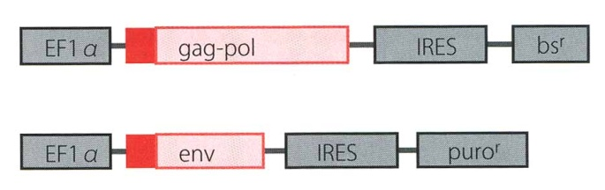
EF1α promotor: 100-fold more potent than the MuL V(murine leukemia virus)-LTR(Long terminal repeats) in 293T cells cf. Retro transposon
bs^{r}:blasticidin resistance gene
puro^{r}:puromycin resistance gene
Red boxes:Kozacks’ consensus sequence:upstream of the initiation codon(ATG) resulting in high expression of virus structural proteins. (6bp:GCCACC).
IRES:internal ribosomal entry site, can make bicistronic vector.
These structural genes(gag-pol, env) were encoded on the two different plasmids three recombination events are two different plasmids, three recombination events are necessary to generate the replication competent retrovirus. A bicistronic vector carrying the IRES sequence was used in the packaging constructs to ensure stable expression of the viral structural genes under the drug selection pressure.

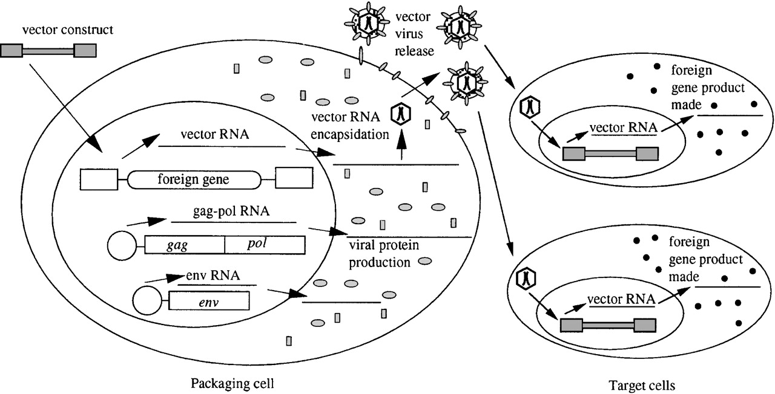
Viral genes expressed from nonretroviral promoters are introduced into cells, where they are stably maintained and where they produce viral structural and enzymatic proteins. When a retroviral vector is introduced into the cell, viral vector RNA can be packaged, resulting in the production of virus particles containing the vector genome. This virus can be harvested and used to infect target cells to introduce the foreign gene on the vector into the cells. Because these target cells do not express viral proteins, the vector will not be propagated further. The viral genes in the packaging cells are not carried along with the vector because they lack the cis-acting sequences necessary for propagation.

Strucure of packaging cell:
ψPackaging signal : LTR backward sequence and a part of gag.
gag:structural protein

pol:protease, retrotranscriptase, integrase
env:envelope.determine host range. cf.ecotorpic MLV→infect rodent, amphotropic MLV→infect many species except for rodent

Retroviral vector plasmid:
Insert:C/EBPβ, Runx2, Cbfβ
Vector:MSCV（Murine Stem Cell Virus）Retroviral Expression System :
pMSCVneo、pMSCVhyg、pMSCVpuro:

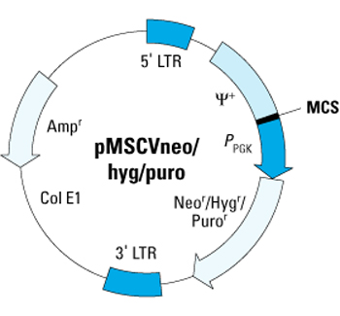
pGC:
Basic structure and the transcript:
○：5’cap, φ：packaging signal, AAAAAAA:polyA, SD: splicing donor, SA: splicing adaptor

Subculturing:
1:6
70% confluent
2～3 days intervals
Drug selection:5days～1week
Materials:
Medium 10ml
DMEM low-glucose
10% fetal calf serum(FCS)
1μg/mL puromycin
10μg/mL blasticidin
Penicillin and streptomycin
PLAT-A: collagen dish
PLAT-E: normal dish

Establishing Plat-E Cultures from Frozen Cells and Drug selection:
- After quickly thawing the cells in a 37℃ water bath, immediately transfer the thawed cell suspension into a 15mL tube containing 10mL of culture medium.
- Centrifuge the tube for 5 min at 1300 to 1500 rpm.
- Discard the supernatant and break the cell pellet by finger tapping.
- Add a few drops of culture medium with gentle shaking and finger tap the tube a few times.
- Add 2ml of culture medium to the tube and gently pipet the cell suspension up and down twice.
- Placed 2μl of 5mg/μl Puromycin, 10μl of 10mg/μl Blasticidin on a 10cm dish.
- Transfer the cell suspension to a 10 cm culture dish containing 8 mL of culture medium.
- Swirl the culture plate well to mix the cells, then incubate the cells for three days before expansion.
Don’t change the culture medium during the first three days. It is normal to see some cells floating after the first 24 hours.
Don’t culture cells to complete confluency. Split cells 4X to 6X every two to three days when the culture reaches 70-90% confluency.

Drug selection and Splitting the Cells:
Avoid forming bubbles as much as possible during this procedure.
- Drug selection:(Placed 2μl of 5mg/μl Puromycin, 10μl of 10mg/μl Blasticidin on a 10cm dish.)
- Added 10ml of DMEM low-glucose(10%FCS 1%P/S) to the dish.
- Wash cells once with PBS.
- Add 1mL of 0.05% Trypsin/0.5mM EDTA solution to a 10 cm dish and incubate at 37℃ for 30 sec.
- Remove the cells from the dish surface by tapping the rim of the culture dish.
- Transfer 10mL of the culture medium to a 50 mL tube.
- Using the same pipette with some residual culture medium, wash the dish surface gently three times in 4 mL of the Trypsin/EDTA solution.
- Gently pipette the cell suspension up and down 7 times and transfer the cell suspension into the 50mL tube containing 10mL medium from step 4.
- Centrifuge the cells for 3 min at 1500rpm.
- Discard the supernatant and break the cell pellet by finger tapping.
- Add 3ml of culture medium, and gently pipet the cell suspension up and down twice then count and seed the cells at the rate of each 500μl. Typically 10⁷ cells can be harvested from one 10 cm culture dish.

Calcium phosphate transfection (Promega, ProFection® Mammalian Transfection System):
Day1(transfection)
- Medium change one day before the transfection. The cells should be at 90-100% confluency the day of transfection. An optimal plating density produces a near confluent dish, which is usually about 48 hours after the transfection.
- DNA suspension(376μl-40μg) was added with 124μl of CaCl₂ and mixed well by vortexing.
- The mixture was added into 500μl of 2×HBS(HEPES-Buffered Saline) slowly (dropwise) and vortexed gently.
- Incubate the combined solution at RT for 30min.※Calcium phosphate-mediated transfection involves mixing DNA directly with CaCl₂ and a phosphate buffer to form a fine precipitate.
- Vortex again and then immediately add the solution, dropwise, to cells.
- Swirl plate to distribute. Incubate at 37℃ with 5%CO₂ for 24hrs.

Day2(medium change)
- Discard the medium.
- Add 4ml of DMEM High-Glucose(10%FCS, 1/100P/S) gently.
- Incubate it at 37℃ with 5%CO₂ overnight.

Day3(collection of 24hrs retrovirus)
- Prepare for seal(TOUGH-SPOTS) and ice box.
- Culture medium was filtered into 4×1.5ml micro-centrifuge tubes with 18G or 20G needle, 5ml syringe, and syringe filter.
- Store the tubes at -130℃ to avoid to decrease titer.
- A total 4ml of high-glucose DMEM was added to the plate.
- Incubate it at 37℃ with 5%CO₂ for 24hrs.
Filter: PALL Life Science, Acrodisc Syrnge Filter
0.45mm HT Tuffryn Membrane, Low Protein Binding, Non-Pyrogenic PN 4184

Day4(collection of 48hrs retrovirus and FACS analysis of the transfection efficiency)
- Culture medium was filtered into 4×1.5ml micro-centrifuge tubes and stored.
- Add 1ml of PBS into a plate (GFP: analyze of fluorescence), and harvest cells by pipetting with scraper.
- Transfer cells into 1.5ml tube and centrifuge at 4000rpm for 2min.
- Aspirate the supernatant.
- Transfer each 30μl of re-suspended cells into 1.5ml tube (GFP and hCD4).
- Centrifuge at 4000rpm for 1min.
- Aspirate the supernatant and store at －130℃ for Western blot.

FACS analyzer:
GFP
- Analyze fluorescence by a fluorescence microscope.
- 30μl of re-suspended cells was centrifuged at 4000rpm for 1min and aspirate the supernatant.
- Cells were re-suspended with 1ml of PBS or FACS buffer containing 1μl of PI(Stock:2mg/ml→2μg/ml(1000-fold dilution)) for FACS analysis.
- Filtrate to a FACS tube with membrane.
- Fluorescence analysis by a FACS calibur.

hCD4
- 30μl of re-suspended cells was centrifuged at 4000rpm for 1min and aspirate the supernatant.
- Add 3μl of PE-hCD4 and the cells were incubated on ice for 20min in the dark.
- 1ml of PBS was added into the mixture and centrifuge at 4000rpm for 1min.
- Supernatant was discarded.
- Cells were re-suspended with 1ml of PBS or FACS buffer containing 1μl of PI(1:1000dilution) for FACS analysis.
- Filtrate to a FACS tube.
- Fluorescence analysis by a FACS calibur.

Infection:
Floating cells:
- Suspend 0.5ml of virus stock and 2 ×10⁵ target cells
- Add polybrene to reach final conc.4～10μg/ml. ※Notice the toxicity of polybrene.
- Culture it in 24well plate.
- Add 0.5ml of the medium after 4～8 hours.
- The next day, add 1.5 ml of the medium into the well and divide the cells into two wells.
- The day after, check the efficiency of infection.

Adherent cells:70% confluent mHAT9d:1×10⁷ cells/ml
- Culture 2×10⁵ target cells(1/50) in 24well plate(BD Falcon).
- Add 0.5ml of the medium containing virus concentration solution and polybrene (final conc.4～10μg/ml) into the cells.
- Add 0.5ml of the medium after 4～8 hours.
- The next day, add 1.5 ml of the medium into the well and divide the cells into two wells.
- The day after, check the efficiency of infection.

Virus concentration:Retro-XTM Concentrator Protocol-at-a-Glance
- Harvest the retrovirus-containing supernatants.
- Take Retrovirus stocks from No.100Box(−130℃) and unfreeze them.
- Transfer clarified supernatant to a sterile container and combine 1 volume of 4×Retro-X Concentrator with 3 volumes of clarified supernatant. Mix by gentle inversion. Lager volumes
Retrovirus 1000μl
Retro-X Concentrator 330μl
Total 1330μl
- Incubate mixture overnight at 4℃.
- Centrifuge sample at 1,500×g for 45 min. at 4℃. After centrifugation, an off-white pellet will be visible.
- Carefully remove supernatant, taking care not to disturb the pellet.
- Gently resuspend the pellet in 1/10 to 1/100th of the original volume using medium. The pellet can be somewhat sticky at first, but will go into suspension quickly.
- Immediately titrate sample or store at −70℃ in single-use aliquots.
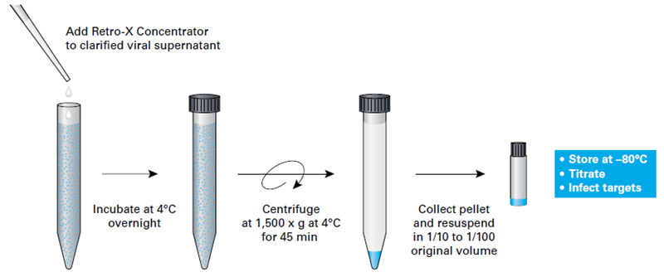
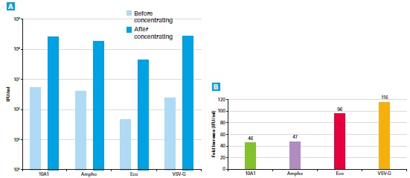
Virus concentration:
Move to P3 room.
Centrifuge it for 16 hours at 4℃, 8000G.
Aspirate the supernatant.
Resuspend the pellet using medium.

Virus titer:
Number of virus particles(Units)/Amount of media(ml)
$$\frac{(\%GFP or YFP positive cells)×number of cells transduced}{volum of virus(ml)}$$

MOI(multiplicity of infection):
Number of virus particles(Units)/number of infected cells(cells)

