Mycoplasma Detection

Mycoplasma:
mycoplasmas produce a variety of effects on cultured cells (e.g. changes in metabolism, immunologic or biochemical properties, growth, viability, etc.).
Mycoplasma is a genus of bacteria that lack a cell wall around their cell membrane. Without a cell wall, they are unaffected by many common antibiotics such as penicillin or other beta-lactam antibiotics that target cell wall synthesis. Mycoplasmae may induce cellular changes, including chromosome aberrations, changes in metabolism and cell growth. Severe Mycoplasma infections may destroy a cell line. Detection techniques include DNA Probe, enzyme immunoassays, PCR, plating on sensitive agar and staining with a DNA stain including DAPI or Hoechst.
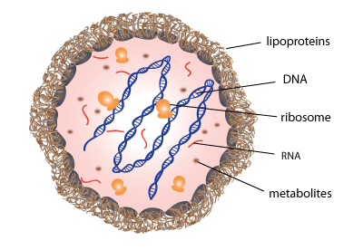
Detection techniques include DNA Probe, enzyme immunoassays, PCR, plating on sensitive agar and staining with a DNA stain including DAPI or Hoechst.
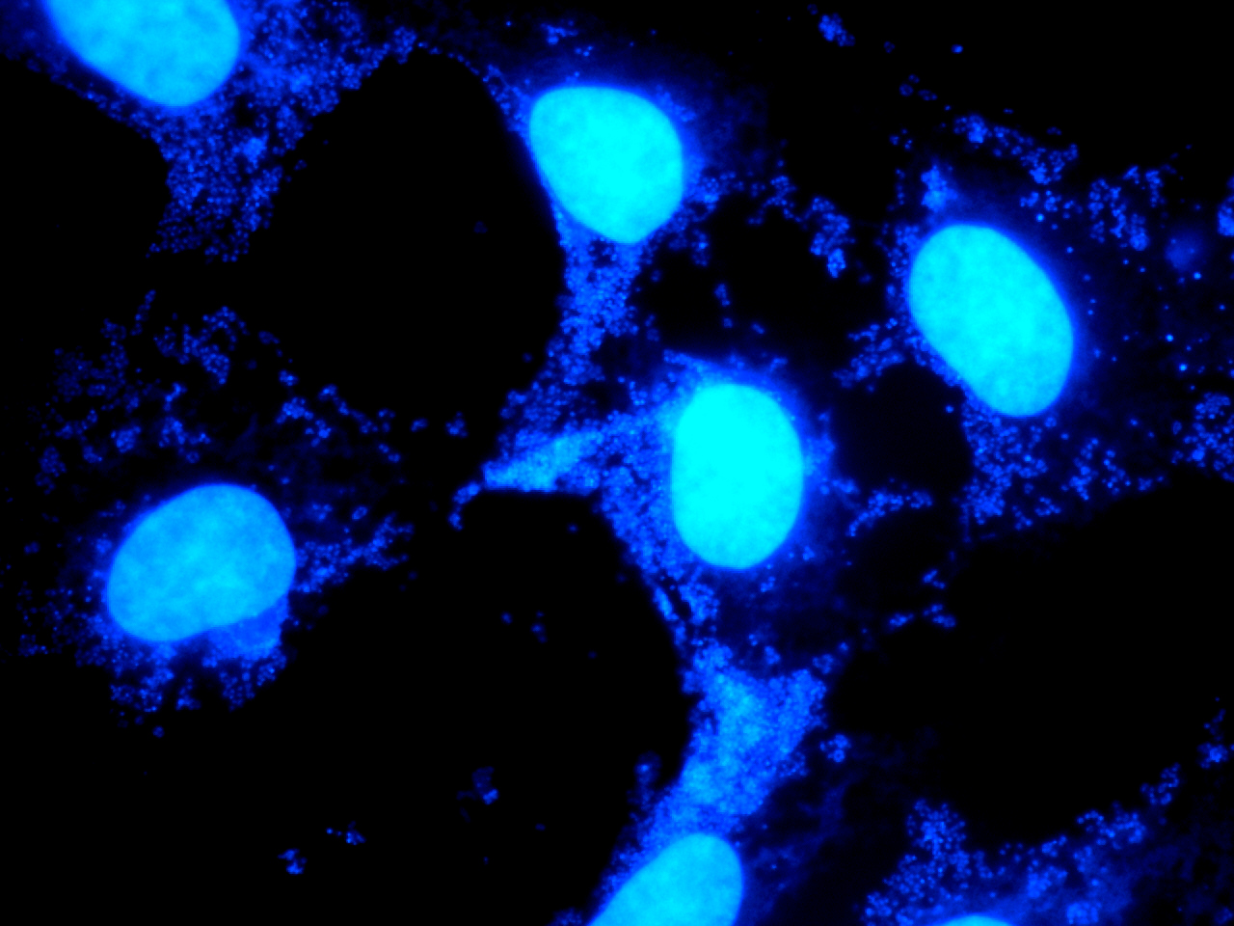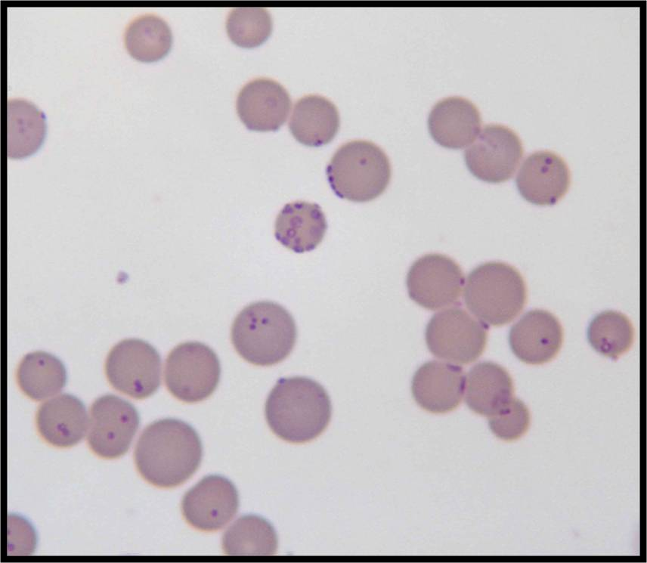M. Haemofelis, Wright-Geiemsa Staining 100X
Mycoplasma is lacated in membrane of cells.

Principle of assay : MycoAlertTM
The MycoAlert™ Mycoplasma Detection Kit is a selective biochemical test that exploits the activity of mycoplasmal enzymes which are found in all six of the main mycoplasma cell culture contaminants and the vast majority of 180 mycoplasma species, but are not present in eukaryotic cells. Viable mycoplasma in a test sample (cell supernatant) are lysed and the enzymes react with the MycoAlert™ Substrate, catalyzing the conversion of ADP to ATP. The ATP is then transferred into a light signal via the luciferase enzyme in the MycoAlert™ Reagent. By measuring the level of ATP in a sample both before (read A) and after the addition of the MycoAlert™ Substrate (read B), a ratio can be obtained which is indicative of the presence or absence of mycoplasma.

Materials and :
MycoAlertTM Mycoplasma Detction Kit for 10 samples
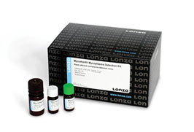
Luminometer
Micropipette(for 200μl) 1
Saline 5ml
Cotton swab for head-count

Procedure:
Prepare for microtubes containing 500μ1 of saline.
Take plaque and saliva samples from buccal side of molars with cotton scrabbly.
Wash the cotton swab in saline.
Take all the suspension, and filtrate it with 0.2μm.
Transfer 50μl of filtrate into another tube.
Add 50μl of MycoalertTM Reagent, place it for 5 min.
Measure amount of luminescence(Reading A) with luminometer.
Add 50μl of MycoalertTM Substrate, place it for 10 min.
Measure amount of luminescence(Reading B).
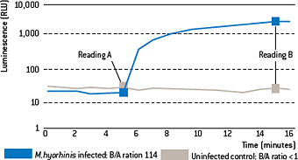

Criterion:
B/A<1=negative
B/A>1.2=positive
1<B/A<1.2=Demanding a retest.

